**Capabilities covered:**

* Use C# Programming to implement business layer of your application

Exercises For Hotel Management

1. Create a class Hotel with the following data members and methods

Data

hotelId : long

briefNote : String

hotelName:String

photoURL:String

starRanking:int

Methods

Set methods and get methods for the data members

Write a class HotelMgr with two methods

storeData()

-which takes the Hotel object as an argument and returns the same.

-Accepts user input for hotel data and sets the data on the object.

showData() which takes an Hotel object as argument and displays the data from the object

Write a class TestMain with the main method

Create an instance of the Hotel object and pass the same to the storeData() and showData()

Constructors

1. Write a class User having the following data members
   * userId: long
   * createdDate:String
   * dateOfBirth:String
   * fullName:String
   * gender:String
   * loginId: String
   * username:String
   * password:String

Write a parameterized constructor which takes the above values

Create a class UserManager which has following methods

* createUser(User user)
* showUserDetails(User user)

1. Write a class HotelBooking having the following data members
   * bookingId:long
   * costPerDay:float
   * fromDate:String
   * toDate:String
   * noOfPeople:int
   * noOfRooms:int

Write a parameterized constructor which takes the above values. Create a class HotelBookingManager which has following methods

* createBooking(HotelBooking booking)
* showBookingDetails(HotelBooking booking)

1. Write a class Person with data members

String name

int age

char sex

and write appropriate setter and getter methods.

Write the equals() method to check for equality

Create two instances of the Person class and pass the data. Check if the two person instances are same by using the equals() method and display the same.

1. Consider the class Hotel with the following data members

hotelId : long

briefNote : String

hotelName:String

photoURL:String

starRanking:int

Override the equals() to check for equality. Check if the two hotel instances are

same by using the equals() method and display the same.

1. Abstract Classes

A Hotel has only 2 types of Rooms, Conference Room or GuestRoom

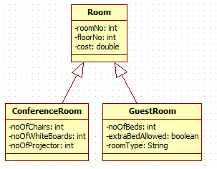

Design Classes for the Class Diagram shown.

Create a class RoomBookingManager which has following methods

* bookRoom(Room room)
* showRoomDetails(Room room)

1. Exception Handling

Consider class User having the following data members

* + userId: long
  + createdDate:String
  + dateOfBirth:String
  + fullName:String
  + gender:String
  + loginId: String
  + username:String
  + password:String

Write User Defined Exceptions to handle the following:

When creating a new user the

1. If the length of loginId is less than 5 chars then give out an InvalidLoginIdException
2. If the password donot contain numbers or is not a combination of capital or small case chars or if the length is less than 5 chars then give out an InvalidPasswordException

Use the existing methods of class UserManager implement these new restrictions

* createUser(User user)
* showUserDetails(User user)

Exception Handling : Throw vs Throws

1. Create the Class UserConsole with the following methods

public User acceptUserDetails()

public void showUserDetails()

public void printMessage(String message)

These methods can use Scanner to accept details of the new user.

Modify the methods in the class UserManager to call the methods of class UserConsole .

The UserManager class has already implemented the restrictions on loginId and password. But now if the loginId or the password entered by the user violates restrictions then he must communicate to the UserConsole who in turn will let the User know.

If the user has entered all the details correctly then the UserConsole class can use the printMessage() to print a Welcome message to the user.

1. Array of Objects

Create POJO classes for the following

Create a class HotelManager with the following methods

* public void createHotel(Hotel hotel)
* public void showHotelDetails(Hotel hotel)
* public void showReviewsForHotel(Hotel hotel)

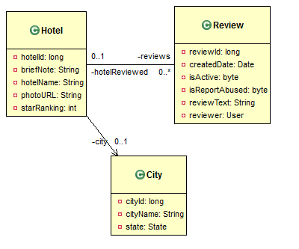

1. ArrayList

Modify the program to include ArrayList

Modify class HotelManager with the following methods

* public void createHotel(Hotel hotel)
* public void showHotelDetails(Hotel hotel)
* public void showReviewsForHotel(Hotel hotel)



11 Program the following classes with appropriate Service Classes

